EX : 01 REG.NO : 210701307

# Downloading and installing Hadoop, Understanding different Hadoop modes,

**Startup scripts, Configuration files.**

**AIM:**

To Download and install Hadoop, Understanding different Hadoop modes, Startup scripts, Configuration files.

**Procedure:**

# Step 1 : Install Java Development Kit

The default Ubuntu repositories contain Java 8 and Java 11 both. But, Install Java 8 because hive only works on this version. Use the following command to install it.

**$ sudo apt update && sudo apt install openjdk-8-jdk**

# Step 2 : Verify the Java version

Once installed, verify the installed version of Java with the following command: **$ java -version Output:**

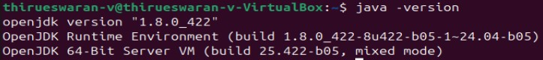

# Step 3: Install SSH

SSH (Secure Shell) installation is vital for Hadoop as it enables secure communication between nodes in the Hadoop cluster. This ensures data integrity, confidentiality, and allows for efficient distributed processing of data across the cluster.

# $ sudo apt install ssh

**Step 4 : Create the hadoop user :**

All the Hadoop components will run as the user that you create for Apache Hadoop, and the user will also be used for logging in to Hadoop’s web interface.

Run the command to create user and set password:

**$ sudo adduser hadoop Output:**

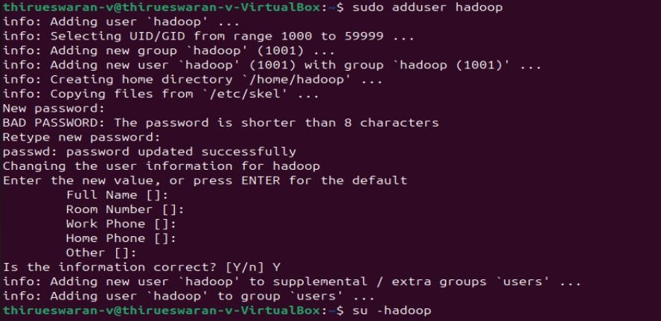

**Step 5 : Switch user**

Switch to the newly created hadoop user:

**$ su - hadoop**

# Step 6 : Configure SSH

Now configure password-less SSH access for the newly created hadoop user, so didn’t enter the key to save file and passphrase. Generate an SSH keypair (generate Public and Private Key

Pairs) first.

# $ ssh-keygen -t rsa

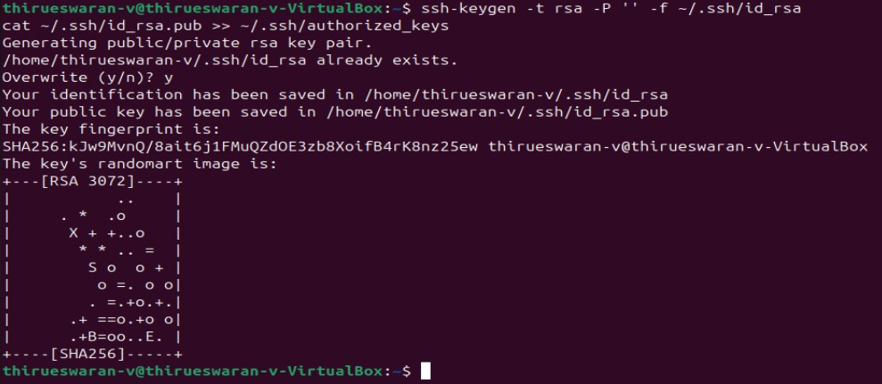

**Step 7 : Set permissions :**

Next, append the generated public keys from id_rsa.pub to authorized_keys and set proper permission:

**$ cat ~/.ssh/id_rsa.pub >> ~/.ssh/authorized_keys**

**$ chmod 640 ~/.ssh/authorized_keys**

**Step 8 : SSH to the localhost**

Next, verify the password less SSH authentication with the following command:

# $ ssh localhost

You will be asked to authenticate hosts by adding RSA keys to known hosts. Type yes and hit Enter to authenticate the localhost:

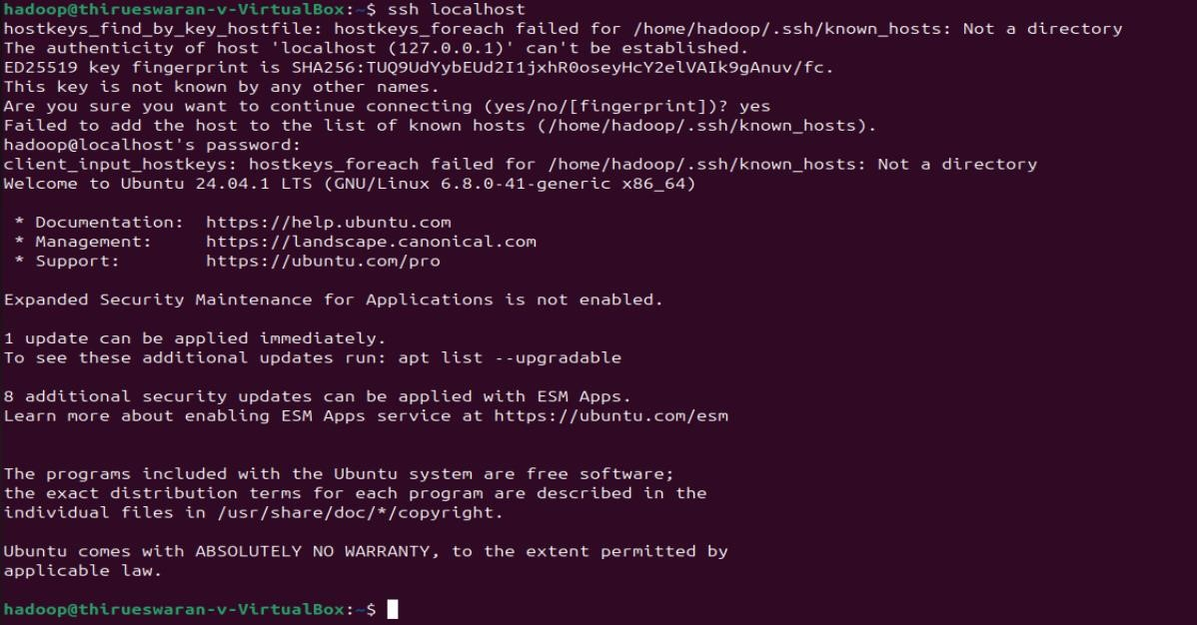

**Step 9 : Switch user**

Again switch to hadoop. So, First, change the user to hadoop with the following command:

**$ su–hadoop**

# Step 10 : Install hadoop

Next, download the latest version of Hadoop using the wget command:

**$ wget**https://downloads.apache.org/hadoop/common/hadoop-3.3.6/hadoop-3.3.6.tar.gz

Once downloaded, extract the downloaded file:

**$ tar -xvzf hadoop-3.3.6.tar.gz**

Next, rename the extracted directory to hadoop:

# $ mv hadoop-3.3.6 hadoop

Next, you will need to configure Hadoop and Java Environment Variables on your system. Open the ~/.bashrc file in your favorite text editor. Use nano editior , to pasting the code we use ctrl+shift+v for saving the file ctrl+x and ctrl+y ,then hit enter:

Next, you will need to configure Hadoop and Java Environment Variables on your system.

Open the ~/.bashrc file in your favorite text editor:

# $ nano ~/.bashrc

Append the below lines to file.

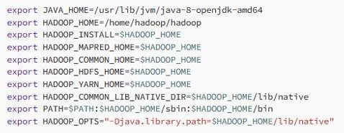

Save and close the file. Then, activate the environment variables with the following command:

# $ source ~/.bashrc

Next, open the Hadoop environment variable file: **$ nano $HADOOP_HOME/etc/hadoop/hadoop-env.sh**

Search for the “export JAVA_HOME” and configure it.

JAVA_HOME=/usr/lib/jvm/java-8-openjdk-amd64

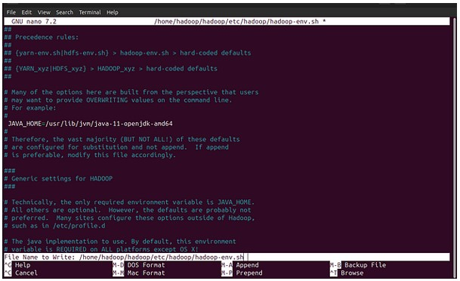

Save and close the file when you are finished.

**Step 11 : Configuring Hadoop :**

First, you will need to create the namenode and datanode directories inside the Hadoop user home directory. Run the following command to create both directories:

**$ cd hadoop/**

**$mkdir -p ~/hadoopdata/hdfs/{namenode,datanode}**

• Next, edit the core-site.xml file and update with your system hostname:

# $nano $HADOOP_HOME/etc/hadoop/core-site.xml

Change the following name as per your system hostname:

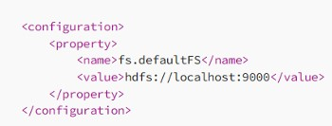

Save and close the file.

Then, edit the hdfs-site.xml file:

# $nano $HADOOP_HOME/etc/hadoop/hdfs-site.xml

• Change the NameNode and DataNode directory paths as shown below:

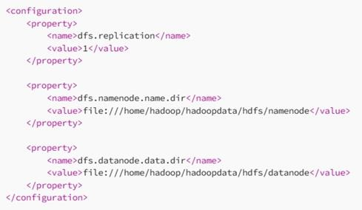

Then, edit the mapred-site.xml file:

# $nano $HADOOP_HOME/etc/hadoop/mapred-site.xml

• Make the following changes:

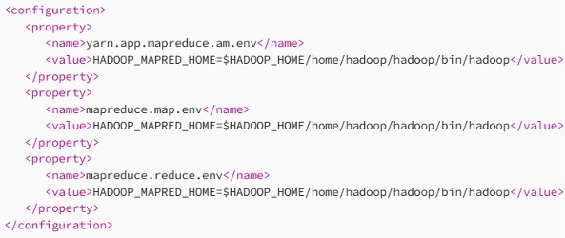

Then, edit the yarn-site.xml file:

**$nano $HADOOP_HOME/etc/hadoop/yarn-site.xml** • Make the following changes:

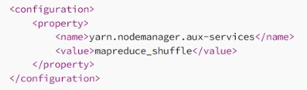

Save the file and close it .

# Step 12 – Start Hadoop Cluster

Before starting the Hadoop cluster. You will need to format the Namenode as a hadoop user.

Run the following command to format the Hadoop Namenode:

# $ hdfs namenode –format

Once the namenode directory is successfully formatted with hdfs file system, you will see the message “Storage directory /home/hadoop/hadoopdata/hdfs/namenode has been successfully formatted “

Then start the Hadoop cluster with the following command. **$ start-all.sh**

You can now check the status of all Hadoop services using the jps command:

# $ jps

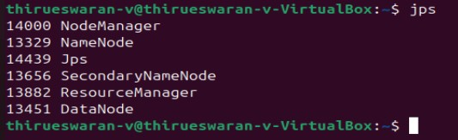

# Step 13 – Access Hadoop Namenode and Resource Manager

• First we need to know our ipaddress, In Ubuntu we need to install net-tools to run ipconfig command,

If you installing net-tools for the first time switch to default user:

# $sudo apt install net-tools

* Then run ifconfig command to know our ip address: **Ifconfig**

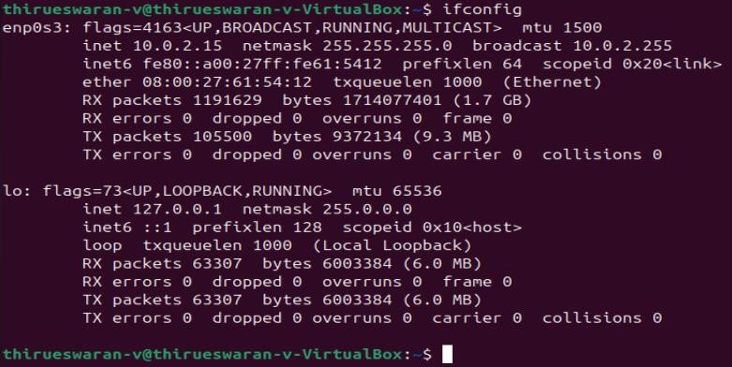

Here my ip address is 192.168.1.6.

* To access the Namenode, open your web browser and visit the URLhttp://your-server-ip:9870
* You should see the following screen: [**http://192.168.1.6:9870**](http://192.168.1.6:9870/)

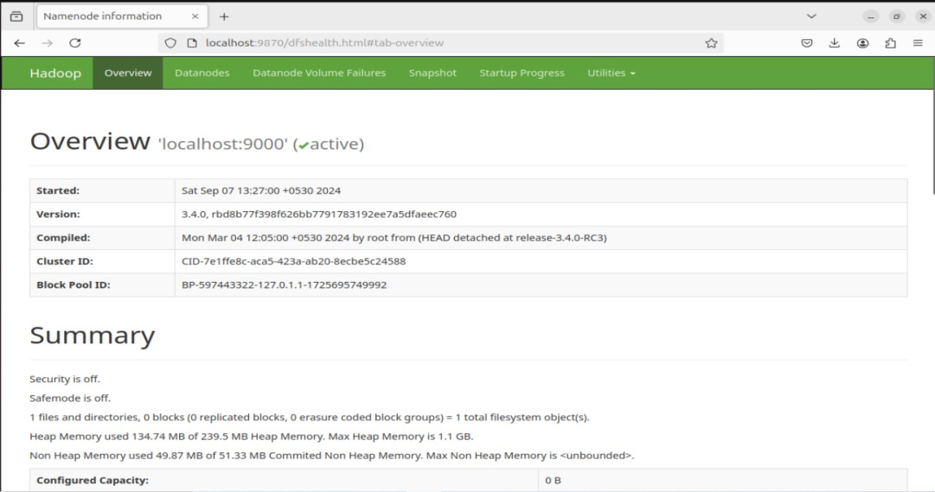

To access Resource Manage, open your web browser and visit the URL http://your-server ip:8088. You should see the following screen: [**http://192.168.16:8088**](http://192.168.0.16:8088/)

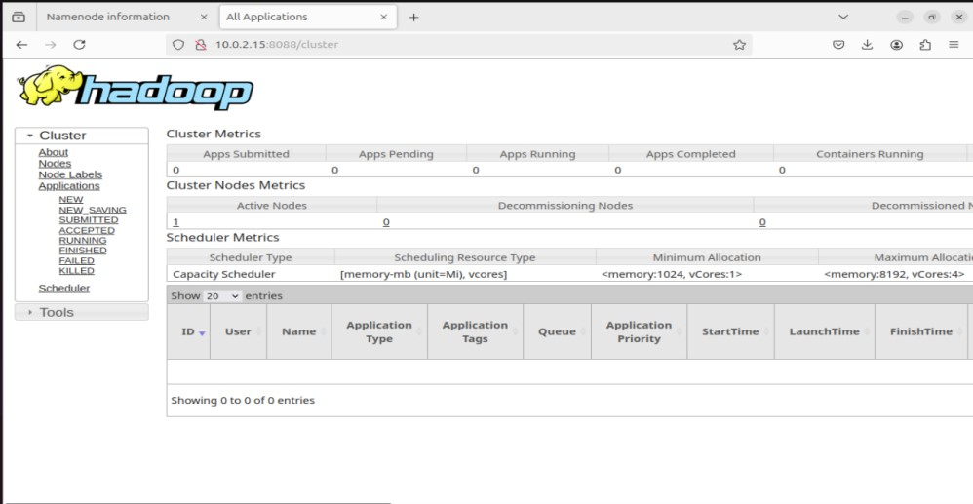

# Step 14 – Verify the Hadoop Cluster

At this point, the Hadoop cluster is installed and configured. Next, we will create some directories in the HDFS filesystem to test the Hadoop.

Let’s create some directories in the HDFS filesystem using the following command:

**$ hdfsdfs -mkdir /test1**

**$ hdfsdfs -mkdir /logs**

Next, run the following command to list the above directory:

# $ hdfs dfs -ls /

Also, put some files to hadoop file system. For the example, putting log files from host machine to hadoop file system.

# $ hdfs dfs -put /var/log/* /logs/

You can also verify the above files and directory in the Hadoop Namenode web interface. Go to the web interface, click on the Utilities => Browse the file system. You should see your directories which you have created earlier in the following screen:

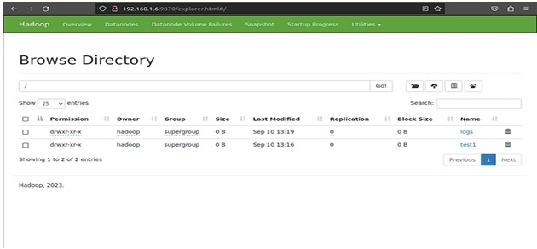

# Step 15 – Stop Hadoop Cluster

To stop the Hadoop all services, run the following command:

**$ stop-all.sh Result:**

The step-by-step installation and configuration of Hadoop on Ubutu linux system have been successfully completed.